2/24/2021

Nadir Hussain

023-18-0025

Computer Networks

Lab-2

**Lab Objectives:**

**Objective:**

**Network Interface Card, cables and Connectors**

**Understand and use basic network commands**

**Part A**

**Study: https://sites.google.com/site/pnutpck11/making-ethernet-cables**

**Task: make straight and cross cable connectors**

**Network Interface card:**

**It is a hardware component responsible for communication among devices.**

**Cables:**

**Cable is the basic medium of communication and data transmission, we usually use Ethernet cable with different categories. CAT5 and CAT6 are currently most use Ethernet cables.**

**Connectors:**

**We use connectors to connect cables with NIC. RJ45 is used to achieve the purpose.**

**Making and Ethernet cable**

**We can make 2 types of cables from bulk of Ethernet and RJ45.**

1. **Crossover cables**
2. **Straight through cables**

**Crossover cable:**

**We make crossover cable to directly connect one computer to another computer without connecting to Switch or router.**

**Straight through cable:**

**When centralized device is used to connect multiple devices we make straight through cable. The receiver end of one device is connected to receiver end of other device and same goes for transmission end.**

**Here we just make crossover cable**

**Step1: Take an Ethernet cable bulk, cut it for your required length using cutter.**

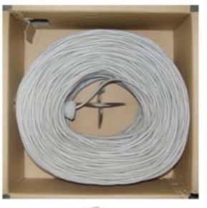

**Bulk Ethernet cable-CAT5 or CAT6**

**Cable Cutter**

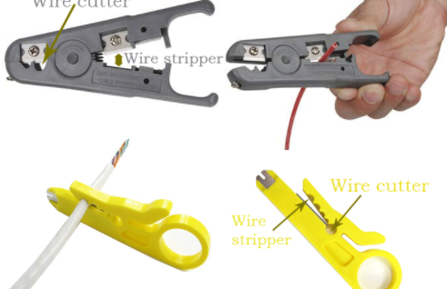

**Step2: Uncover the cable using crimping tool about 1 inch. Crimping tool has the razor blade which will uncover the cable.**

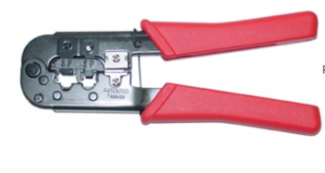

**Crimping tool**

**Step3: You will get eight small wires after uncovering.**

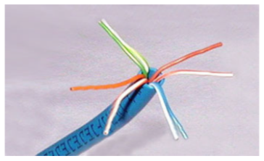

**Unstripped wires**

**Separate them by their colors and make straight.**

**Step4: Follow the color combination to combine colors, the combination goes as**

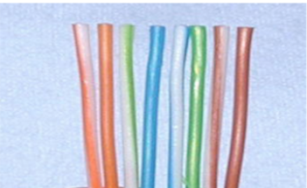

**Standard cable color combination.**

**Step5: Cut the colored cables into half, Take RJ45 and put the unstripped wires into it keeping in mind their combination.**

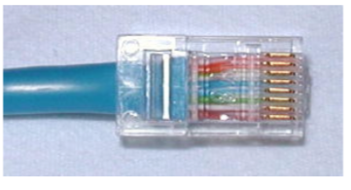

**RJ45 with Ethernet cable.**

**Repeat the same steps to make other end of wire.**

**Using eNSP to create network**

**eNSP provide variety of conections, end devices, switches, routers etc to simulate the network when there are less resources to afford the hardware.**

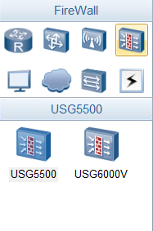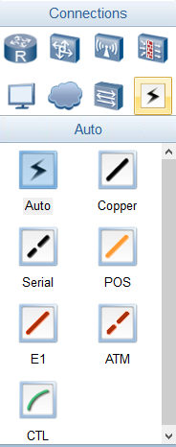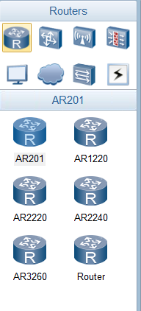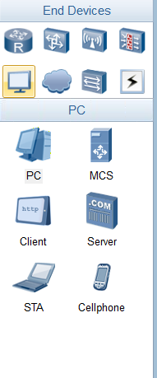

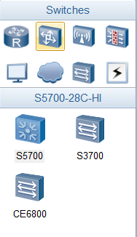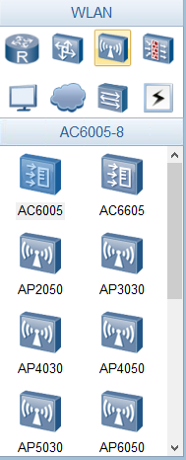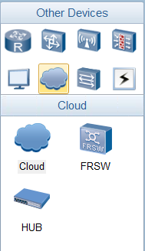

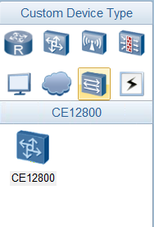

**Here we create a 2 device network to ping their status on network.**

**Drag and drop 2 PCs from end device and one auto connection on eNSP workspace. We call this step as design.**

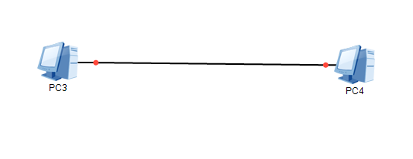

**Assign IPs to both devices.**

**To PC1** 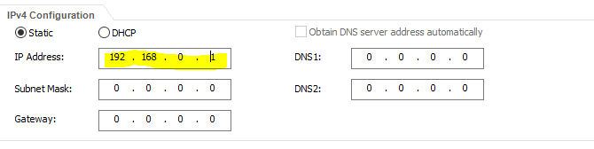

**To PC2**

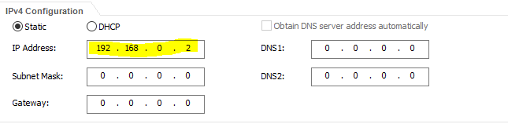

**We usually assign 192.168.0.0 to 192.168.0.256 IP addresses for testing purpose.**

**Now start the network**

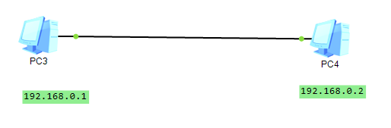

**A green sign on both ends show that PCs have been started.**

**Ping from PC1 to PC2, we use Command prompt provided by eNSP**

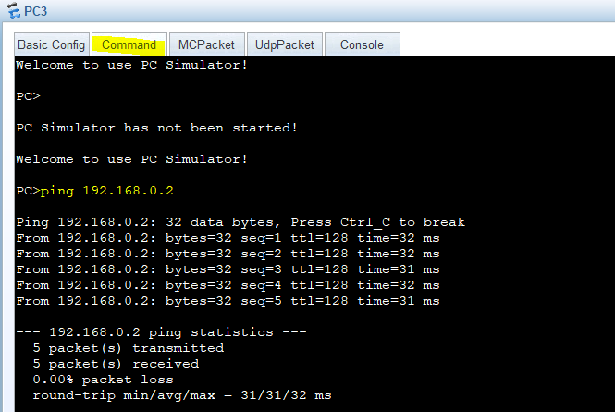

**In eNSP ping command sends 5 packets unlike in windows prompt which sends 4 packets.**

**We see all 5 packets were received by the host at IP 192.168.0.2 and our connection is working properly.**

**We can launch wireshark directly from eNSP and observe the network operations.**

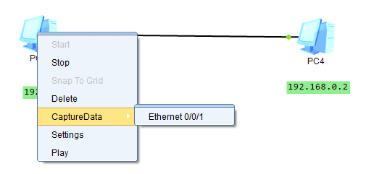

**Clicking on capture data will launch wireshark.**

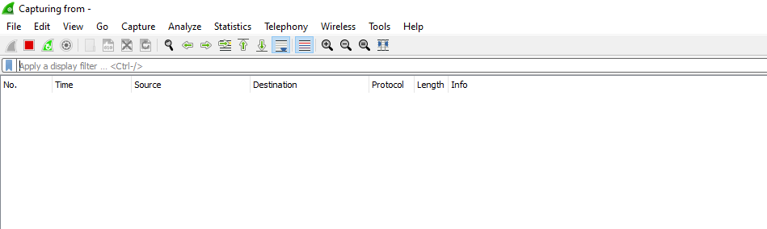

**At first wireshark is empty.**

**Now we ping from PC1 to PC2 and then observe the network.**

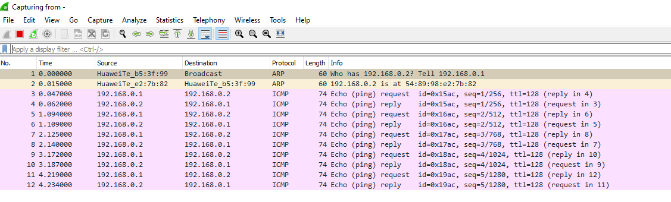

**At first the source is HuweiTe_bs:3f:99 and destination is Broadcast because no connection exist at this point. ARP protocol is used by the network to introduce devices to each other. Its asks “Who” is being pinged and asks to reply to the PC who has pinged.**

**Then ICMP protocol is used when connection is built and PC1 shares packets of data to PC2. ICMP is internet control message protocol which is used by ping protocol to transmit message over network.**

**The End**

**The End**